Instructions for Trade on Behalf process in the Hungarian auction

Dear member,
The Trade on Behalf (ToB) process aims to be a supporting tool when isolated issues occur disrupting your connection with the ETS system. In this case, you can download the excel forms from our website for the respective auction from this link
The ToB process is meant to be operated on a best effort basis, this is why we advise you to call our Market Operations department as of when you have e-mailed the forms and also to try to send the form(s) as soon as possible in order to ensure they will be processed correctly (avoid waiting until close to the OBK closure, the latest possible time to send it is 11:45).
Below you will find some basic instructions on how to fill in the form:
- Select the correct form based on the type of order (linear/block) and 25Hours for Long Day DST or the ones for normal day.
- The ones for the normal day should be used for Short Day DST without filing in the impacted periods.
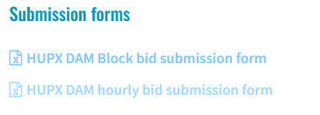

- Fill in the trader name (only authorized traders are allowed to send a ToB form and request its submission) and the respective portfolio as well as the type of the order (new, modification of existing one or cancellation of an existing one)

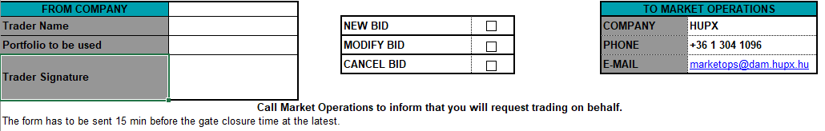

- Ensure that the auction (and area), the trading and delivery days are correct.

- Please add the prices and volumes carefully.

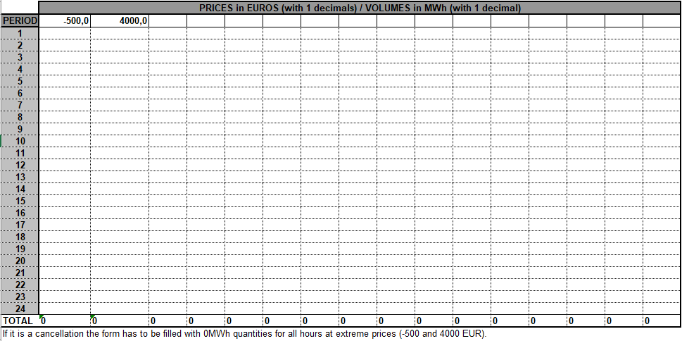

- Send the file(s) via email to Market Operation and also call the team.

Please send the forms via email to : marketops@dam.hupx.hu
And then call: +36 1 304 1096

